AI Model Landscape
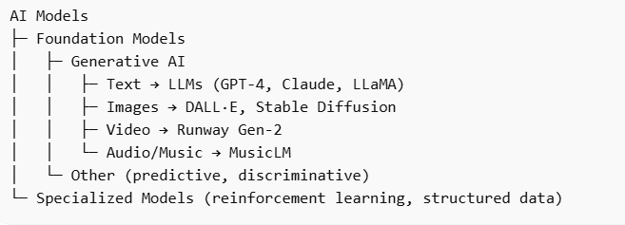
1. Foundation Models
- Large-scale pre-trained models that can be adapted for many tasks.
- Can be unimodal (text, image, audio) or multimodal (text + image + audio).
- Examples: GPT-4, DALL·E, PaLM, LLaMA, Stable Diffusion

2. Generative AI (subset of foundation models)
- AI that creates new content rather than just analyzing it.
- Can include text, image, video, audio, and 3D.
- Subcategories:
Type | Description | Example Models
Text | Generates human-like language | GPT-4, Claude 3, LLaMA 2, Falcon
Image | Creates images from prompts | DALL·E, MidJourney, Stable Diffusion
Video | Generates videos or animations | Runway Gen-2, Synthesia
Audio / Music | Creates speech, sound, or music | MusicLM, AudioGen, VALL-E
3D / Simulation | Generates 3D models or environments | Point-E, Kaedim3D
✅ All LLMs that generate text fall under Generative AI.
⚠️ Not all Generative AI are LLMs (image/video/audio generators aren’t).

3. Large Language Models (LLMs) (subset of text-based Generative AI)
- Specifically trained on text data to understand, summarize, translate, answer questions, and generate text.
- Can also perform code generation, reasoning, and conversation.
- Examples:
  - Proprietary: GPT-4, GPT-4-turbo, Claude 3, Gemini 1.5
  - Open source: LLaMA 2, Falcon 7B, Mistral 7B, RedPajama
Special Notes:
- LLMs can be instruction-tuned (follow user instructions better) or multimodal (accept text + images).
- LLMs often serve as the core engine behind AI assistants like ChatGPT or Claude.

4. Other AI Models
- Discriminative AI / Predictive AI: Focus on classifying or predicting rather than generating.
  - Example: BERT (for understanding text), ResNet (for images), XGBoost (structured data).
- Reinforcement Learning Models: Learn via trial-and-error feedback.
  - Example: AlphaGo, AlphaZero

